RG59+FTTH
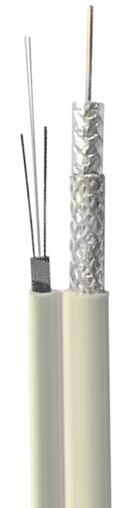
Description
 | Material | Diameter (mm)
Inner Conductor | CCS | 0.81
Dielectric | Foamed PE | 3.68
Al Foil | Bonded APA | 3.88
Overall Braid | Al-Mg
 | FTTH
Jacket | PVC | 6.05

Characteristics
Capacitance | 52 pF/m |  | SRL 5~1000MHz | 18dB Min.
Velocity | 82% |  | Impedance | 75 ± 3 ohms

Attenuation @ 20℃
Frequency  MHz | Attenuation  dB/100m | Attenuation  dB/100ft |  | Frequency  MHz | Attenuation  dB/100m | Attenuation  dB/100ft
55 | 7.66 | 2.34 |  | 500 | 24.51 | 7.48
100 | 10.48 | 3.20 |  | 600 | 27.10 | 8.27
250 | 17.00 | 5.19 |  | 750 | 30.56 | 9.32
300 | 18.74 | 5.72 |  | 1000 | 35.85 | 10.93



